Rheological and Tribological behaviour of Nano fluids: an experimental evaluation
Prashant Thapliyal¹, A. Kumar², G.D. Thakre³
¹Army Cadet College, Indian Military Academy, Dehradun, India
²Assistant Manager, Corporate R&D Centre, APAR Industries Ltd, Navi Mumbai 400701
³Advanced Tribology Research Centre, CSIR-Indian Institute of Petroleum Dehradun, India

prashant.197104@gmail.com
Abstract. Commercially available synthetic engine oils of SAE grades 5W40 were taken as base fluids for preparing nano fluids by blending 0.1% and 0.2% concentration by weight of the functionalized Cu and MoS₂ nanoparticles in them. The base fluids and their blends were characterized using standard ASTM and IS testing methods for their physicochemical and tribo performance behaviours. The rheological studies were performed on a Rheometer while the tribological investigations were performed on tribo-tester. The study reveal that a small improvement in anti- friction behaviour of about 6% and 4% reported for the 0.2 wt% of Cu and MoS₂ nanoparticles respectively in the tested lubricants indicate that finished products have little scope to improve anti-friction properties under the influence of already present additives, however anti-wear properties showed significant enhancement up to 20% for 0.2% MoS₂ and up to 15% for 0.2% nano-Cu indicating better anti-wear properties of MoS₂ and Cu nanoparticle blends. Rheological studies reveal that blending of nanoparticles has marginal influence on the rheological behaviour of the lubricants. The lubricants show shear thinning behaviour at low shear rates. However at higher shear rates, lubricants behave as Newtonian fluids. The nano fluids also reported the Zero shear viscosity and infinite shear viscosity.
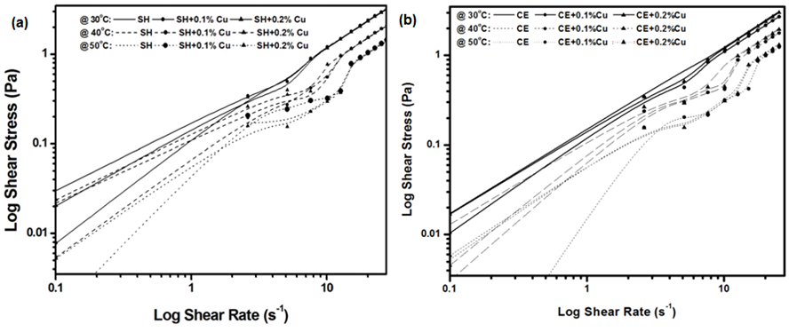
Fig. - Shear stress/shear rate curves for lubricant samples of (a) SH and (b) CE.
Keywords: Tribology, synthesis of Cu and MoS₂ nanofluids, Four-ball trbotester, rheometer, engine oils, apparent yield stress

References:

- Choi, S. U. S. (1995), “Enhancing Thermal Conductivity of Fluids with Nanoparticles,” Developments and Applications of Non-Newtonian Flows, Siginer, D. A. and Wang, H. P. (Eds.), pp 99-105, American Society of Mechanical Engineers, New York.
- Wang, X. Q. and Majumdar, A. S. (2007), “Heat Transfer Characteristics of Nanofluids: A Review,” International Journal of Thermal Science, 46(1), pp 1-19.
- Wang, X. Q. and Majumdar, A. S. (2008), “A Review on Nanofluids-Part I: Theoretical and Numerical Investigations,” Brazilian Journal of Chemical Engineering, 25(4), pp 613-630.
- Wang, X. Q. and Majumdar, A. S. (2008), “A Review on Nanofluids-Part II: Experimental and Applications,” Brazilian Journal of Chemical Engineering, 25(4), pp 613-630.
- Yu, W. and Xie, H. Q. (2012), “A Review on Nanofluids: Preparation, Stability Mechanisms, and Applications,” Journal of Nanomaterials, Article ID 435873, 17 pages, DOI:10.1155/2012/435873.

