Pressure dependent structural phase transition and elastic properties of MnSi compound
Sheetal Malviya*, R. C. Dixit and Netram Kaurav
Department of Physics, Govt. Holkar (Model, Autonomous) Science College, Indore (MP)-452001 India.

*Corresponding author: sheetal7.malviya@gmail.com
Abstract. MnSi is a metallic compound that exhibits a structural phase transition as a function of pressure. At ambient conditions, MnSi has a cubic structure. However, at high pressures, it undergoes a structural phase transition to a NaCl type crystal structure. The pressure-dependent structural phase transition in MnSi has been studied using various experimental and theoretical techniques. In the present work, we have used an efficient inter-ionic potential approach to predict pressure dependent structural phase change and associated volume collapse in MnSi. Therein, the potential includes the long-range Coulomb, van der Waals (vdW) interaction, and the short-range repulsive interaction up to second neighbour ions. It has been demonstrated that the Hafemeister and Flygare approach successfully evaluates the equation of state for change in volume with respect to applied pressure. We have identified a structural phase transition from B1(NaCl) type structure to B2 (CsCl) type structure in this compound. The estimated value of phase transition pressure (Pt) is 41 GPa, which is consistent with the available reported data. The identified first order phase transformation showed a volume collapse of about 10% in the vicinity of transition. In addition, we have also investigated second order of elastic constants for MnSi compound.
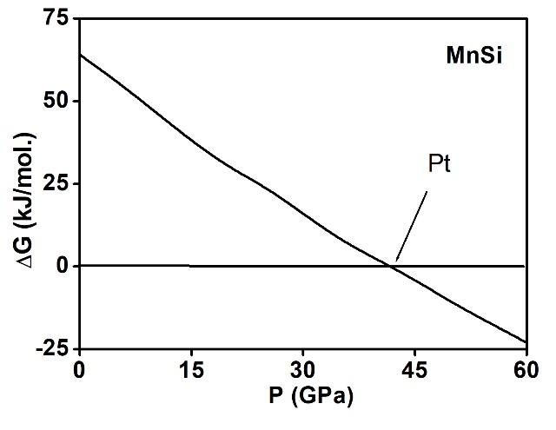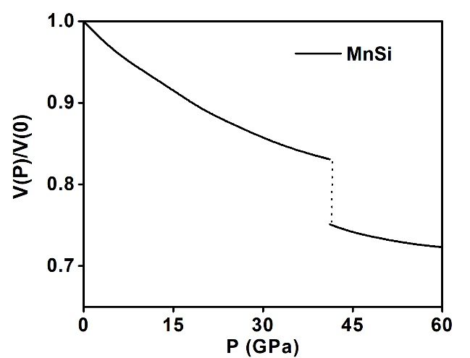
Fig 01: Shows the pressure dependent structural phase transition and volume collapse of MnSi compound.

